TEST DAY 4

16.Reverse a Number

Reverse a Number means moving the digit at the last position to the first position and vice versa.

For example, if the given number is “1234”, the reverse number will be “4321”.

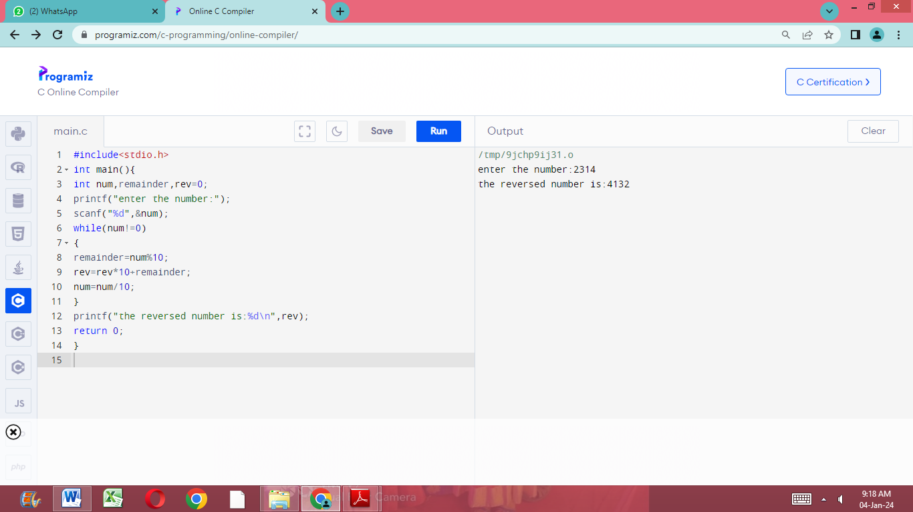

17.Reverse a Number and Check if it is a Palindrome

Problem Description

Accepts an integer, reverse it and also checks if it is a palindrome or not.

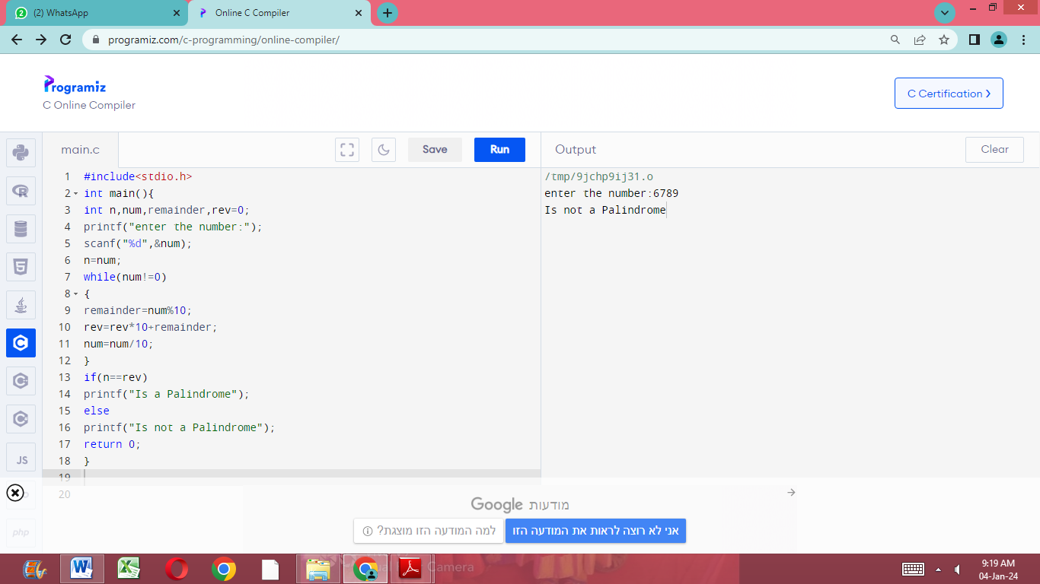

18.C Program to Add Two Binary Numbers

Problem Description

This program finds the sum of two binary numbers.

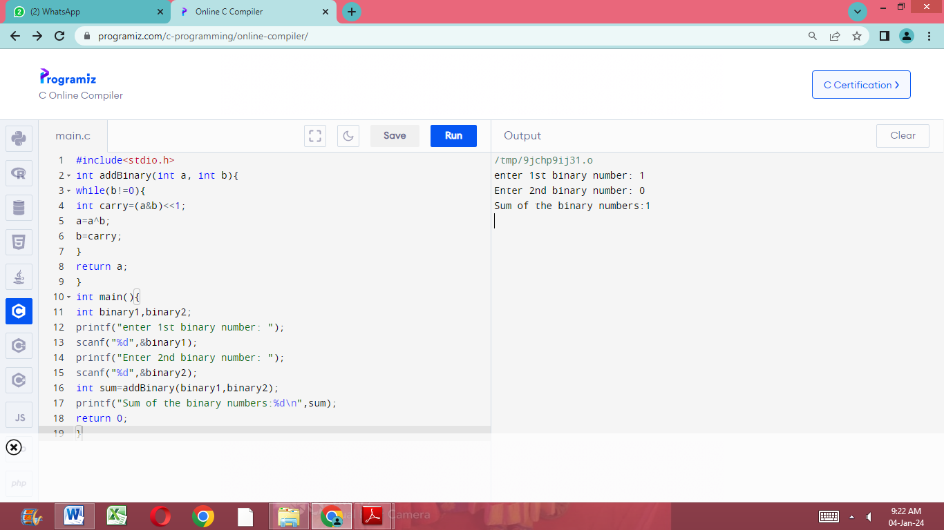

19.Find Prime Numbers in a Given Range

Problem Description

Take the range and finds all the prime numbers between the range and also prints the number of prime numbers.

Case:1

Enter the value of num1 and num2

70 85

Prime numbers are

71

73

79

83

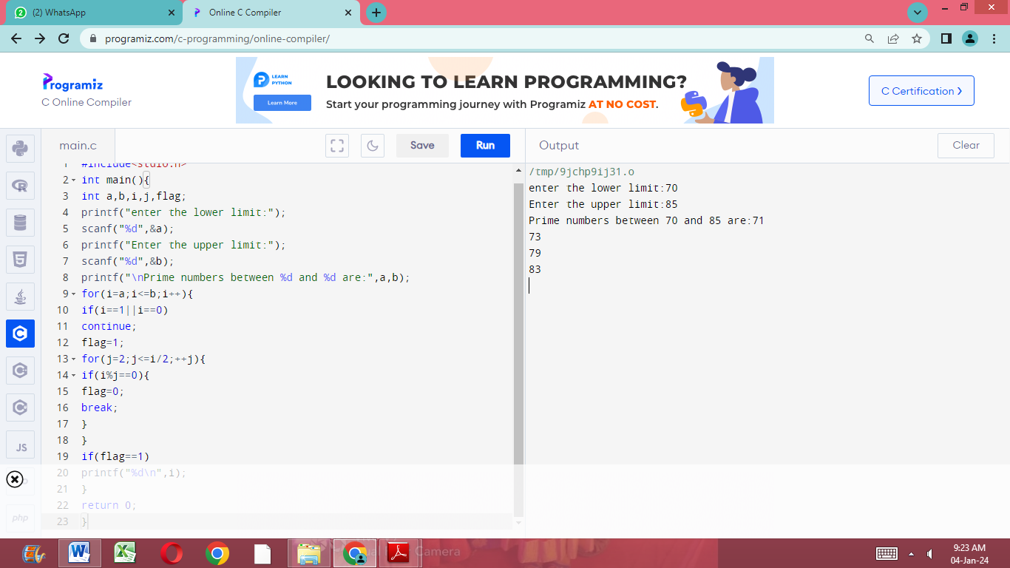

20.Leap Year

Leap Year: A year is a Leap Year if it satisfies the following conditions:

The year is exactly divisible by 400 (such as 2000,2400) or,

The year is exactly divisible by 4 (such as 2008, 2012, 2016) and not a multiple of 100 (such as 1900, 2100, 2200).

